Assignment No: 04

Department of Computer Science

Iqra University Islamabad

Object Oriented Programming

Maqsood Ahmed

ID: 38186

**Problem # 1: [CLO2]**

**Source Code:**

public class Assign_04 {

public static void main(String[] args) {

SavingsAccount savingsAccount = new SavingsAccount(60000, 0.04); // 4% percent interest Rate

System.out.println("\n---------| Cheking Methods for SavingsAccount |----------");

System.out.println("The calculating interest is: " + savingsAccount.calculateInterest());

if(savingsAccount.credit(5000)) {

System.out.println("Deposit Successfully!");

}

if(savingsAccount.debit(1000)) {

System.out.println("Deposit Successfully!");

}

CheckingAccount checkingAccount = new CheckingAccount(70000, 23.44);

System.out.println("\n---------| Cheking Methods for CheckingAccount |---------");

if(checkingAccount.credit(3000)) {

System.out.println("Deposit Successfully! ");

}

if(checkingAccount.debit(2000)) {

System.out.println("Withdraw Successfully! ");

}

System.out.println("\n-------| Checking account type by Dynamic Dispatch |-----");

// dynamic dispatch;

Account dynamicDispatch;

dynamicDispatch = checkingAccount;

checkingAccount.printAccountType();

dynamicDispatch = savingsAccount;

savingsAccount.printAccountType();

}

}

abstract class Account {

protected double balance;

public Account(double balance) {

if (balance < 0.0) {

System.out.println("You entered Invalid Balance!");

this.balance = 0.0;

} else {

this.balance = balance;

}

}

public boolean credit(double amount) {

this.balance += amount;

return true;

}

public boolean debit(double amount) {

if (balance < amount) {

System.out.println("Debit amount exceeded account balance.");

return false;

}

this.balance -= amount;

return true;

}

public double getBalance() {

return balance;

}

abstract public void printAccountType();

}

class SavingsAccount extends Account {

public double interestRate;

public SavingsAccount(double balance, double interestRate) {

super(balance);

this.interestRate = interestRate;

}

public double calculateInterest() {

return interestRate * super.balance;

}

@Override

public void printAccountType() {

System.out.println("It is a Saving Account");

}

}

class CheckingAccount extends Account {

private double feePerTranscation;

public CheckingAccount(double balance, double feePerTranscation) {

super(balance);

this.feePerTranscation = feePerTranscation;

}

@Override

public boolean credit(double amount) {

super.balance += amount;

super.balance -= feePerTranscation;

return true;

}

@Override

public boolean debit(double amount) {

if (balance < amount) {

System.out.print("Debit amount exceeded account balance.");

return false;

}

super.balance -= amount;

super.balance -= feePerTranscation;

return true;

}

@Override

public void printAccountType() {

System.out.println("It is a Checking Account");

}

}

**OUTPUT:**

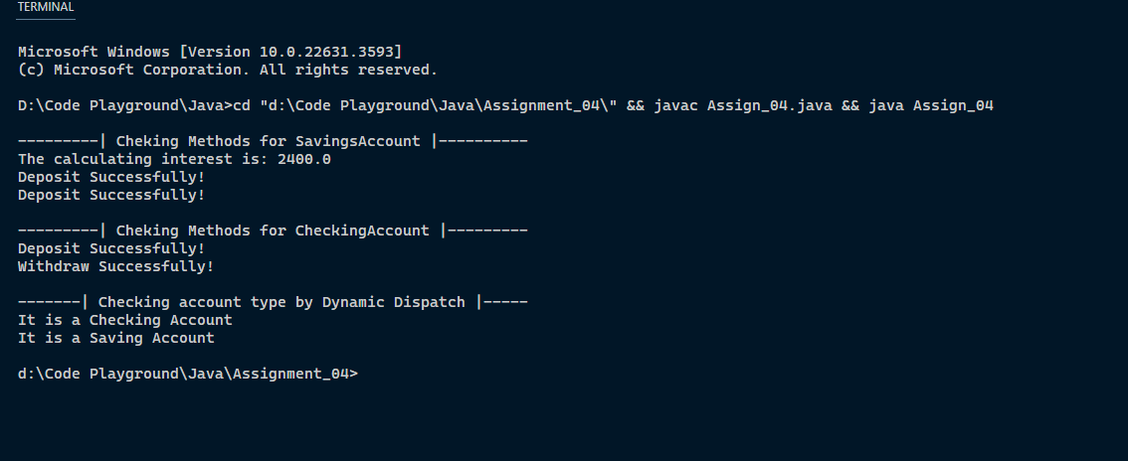

**The End**